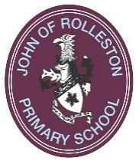
John of Rolleston Primary School

I am writing this last Rollestonian article of our academic year as we enter the last week of term. The weather has been glorious, which makes a pleasant change from past Summer terms, and has allowed all of our outdoor activities to take place. Children have particularly enjoyed being able to play on the school field at break times, even if it resembles a scorched corn field!
Community Day 2018
This Year’s Community day was once again a huge success. The weather held, the stalls all made lots of money and most importantly everyone had lots of fun! A huge thank you must go to the FOJORPS committee as well as all of the helpers who ensured that the event ran smoothly. The total made is around £6500 at the time of writing. The planning for next year will already have started!
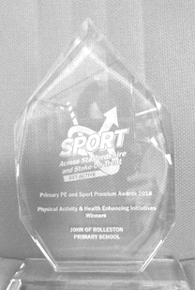
Sports Award
We are thrilled that our work to develop the physical activity of our children has been recognised. We have won a regional award in the Physical Activity and Health Enhancing Initiatives Category.
John of Rolleston introduced active learning across the curriculum and across the school. The project started in the Autumn Term by sending the English, Maths and PE lead on training (Active Maths and Active Literacy). PE Lead, Nicola Bourke, then ran a training session for all staff during an INSET. Staff were also given the opportunity to have a go at a variety of activities ranging across all key stages and curriculum areas. The enthusiasm of the PE lead during the session ensured all staff were on board with the project. All staff are now regularly including active learning into their lessons and it has become part of the school culture. Going forward, the PE lead is keen to involve parents in an active learning workshop to understand the importance of reducing sedentary (inactive) behaviours in their pupils. It is great to see that wonderful work of the staff is recognised! More details at the web link below.
https://sportacrossstaffordshire.co.uk/primary-schools-championed-in-regional-awards/
World War 1 commemoration
You may be aware that 2018 is the 100 year anniversary of the guns falling silent at the end of WW1. As a school we consider that it is important to remember this momentous occasion along with organisations in the village. In the Autumn term we will be carrying out activities with the children, which we will give you more details about in September.
However, in preparation for the event we have created a photograph of a poppy using some of our pupils. The idea was that we commemorate the 153 men from Rolleston who fought in the Great War using the Key Stage 2 children. They held cards in the shape of a huge poppy on the field. The photograph was then taken by a drone overhead.
The photos will be shared with you at a later date.
We are very honoured to be able to play our part with local community groups in commemorating this event.
Year 6 move on
It is the time of year when emotions are torn. We are excited for the Year 6 pupils as they conclude their seven years of Primary Education and have the excitement of secondary school to look forward to. However, we have the sad task of saying goodbye after getting to know them as individuals over the years spent with us. The year group has so many skills amongst them, great mathematicians, artists, musicians, sports men and women and all are hardworking and have been a credit.
The children have been preparing to share a Leavers’ Performance with parents and this is usually a very emotional time. We still have the last day of term to come with the some children traditionally arriving at school in a different form of transport, from bicycles to limousines to tractors and motorcycles.
This year has been another successful one. The children and staff all work tirelessly and this is what makes John of Rolleston the wonderful place that it is. Thank you to parents/ carers for your support and we look forward to continue working with you all in September.
Mr Bateman
and all at John of Rolleston Primary School
website: www.johnofrolleston.com
twitter: JORPS_1

