The Rolleston Engineering and Transport Society
TREATS Railway Station Heritage Group

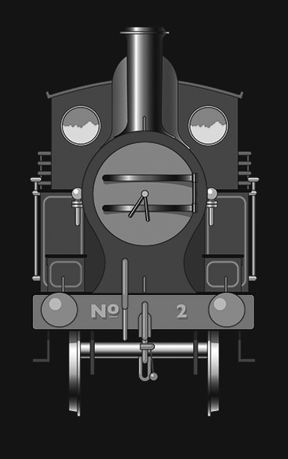
It is most gratifying when a local school or organisation make contact asking to visit the station site. During June when the wildflower meadow looked at its finest, our wishes were granted when we entertained pupils from the two Year 2 classes at John of Rolleston Primary School.
With some of our new information banners in place, the children gathered round the footprint of the booking hall whilst we explained how the building functioned with its four separate rooms – ticket office, general waiting room, ladies room and gentlemen’s convenience. Also the roles of various station employees were explained – the Station Master who’s house remains a dwelling on South Hill, ticket clerk, porter/shunters and permanent-way man who would walk the section of railway daily to inspect the condition of the track.
We explained how trains calling at the two platforms would travel on to different places. Two pupils were appointed to the role of ticket clerk, issuing replica tickets, some for Tutbury and some for Burton. Due to budgetary constraints, all children had to travel third class and some explanation about old currency applicable at the time prior to the station’s closure, was necessary.
Whilst one class enjoyed their imaginary journey, hearing about the many facets of rail travel in years gone-by, the other class received description of the various plants and wildlife, present at the station, by a member of our “Green Team”.
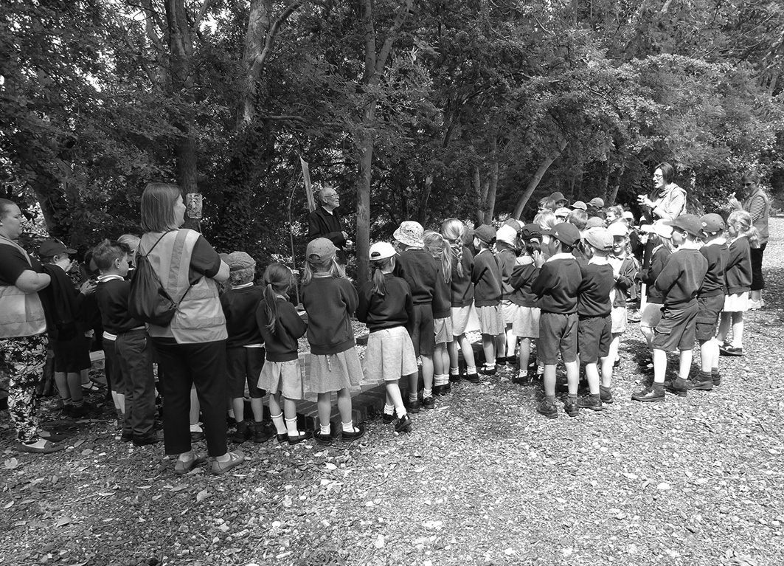

Continuing our relationship with the village school, we took the opportunity to show off our new display material at Community Day on 16th June. Now with four roller banners giving information about the project itself, from its beginnings in 2014 to its present status, as well as the history of the railway network in our area with the aid of period photographs, we are able to present this community initiative more effectively.
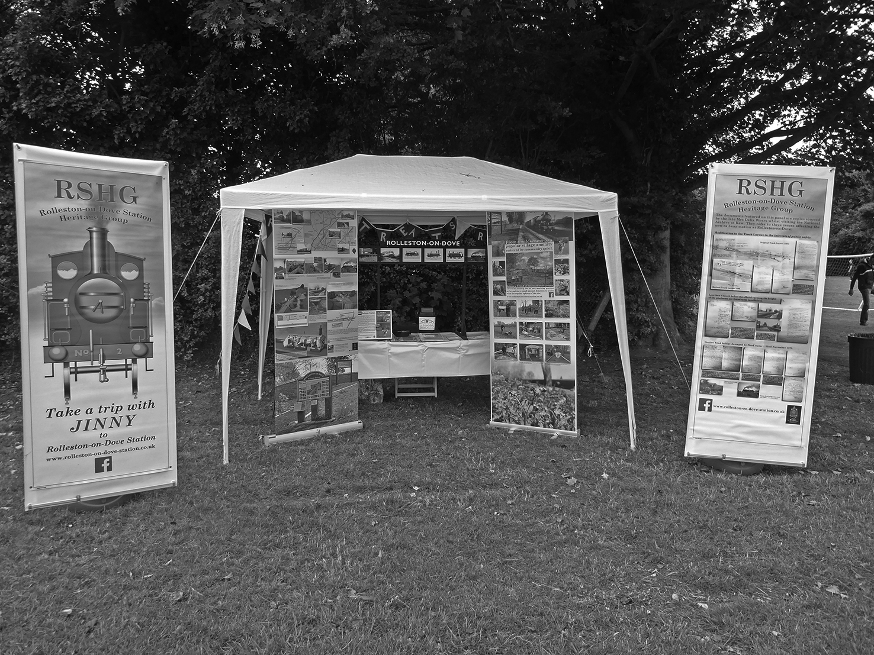
As regular visitors to the site will have noticed the centre section of the wildflower meadow, cleared of a glut of oxeye daisies last autumn and re-planted in the spring, has been the most successful during this summer. It is our intention during autumn to clear the other two sections of grass and weeds in readiness for re-seeding next spring so that hopefully an all-over effect will be achieved.
Our website is regularly updated:
www.rolleston-on-dove-station.co.uk
Or find us on Facebook:
www.facebook.com/pages/Rolleston-on-Dove-Railway-Station/393619157480649

