St Mary’s 13th Advent Festival: Opening Concert
Friday 30th November, 7.30 pm

The Mellstock Band
presents
The Leaves of Life
Christmas Music from English Tradition
from Carols to Revels and from Alehouse to Church Gallery

A costume performance with early & modern instruments,
with tales and poems by Thomas Hardy, William Barnes,
John Clare, Charles Dickens and others

In their Christmas show for 2018, The Mellstock Band combine the symbolism of trees, tales of shepherds and their sheep, winter-time feasting and strange visitations. The Leaves of Life also explores some of the beliefs and superstitions that surround mid-winter festivities, drawing on seasonal ballads and folk carols as well as west gallery music and village band tunes. The band are as always dressed in rural Sunday-best for the 1840s, and play instruments of Thomas Hardy’s time.
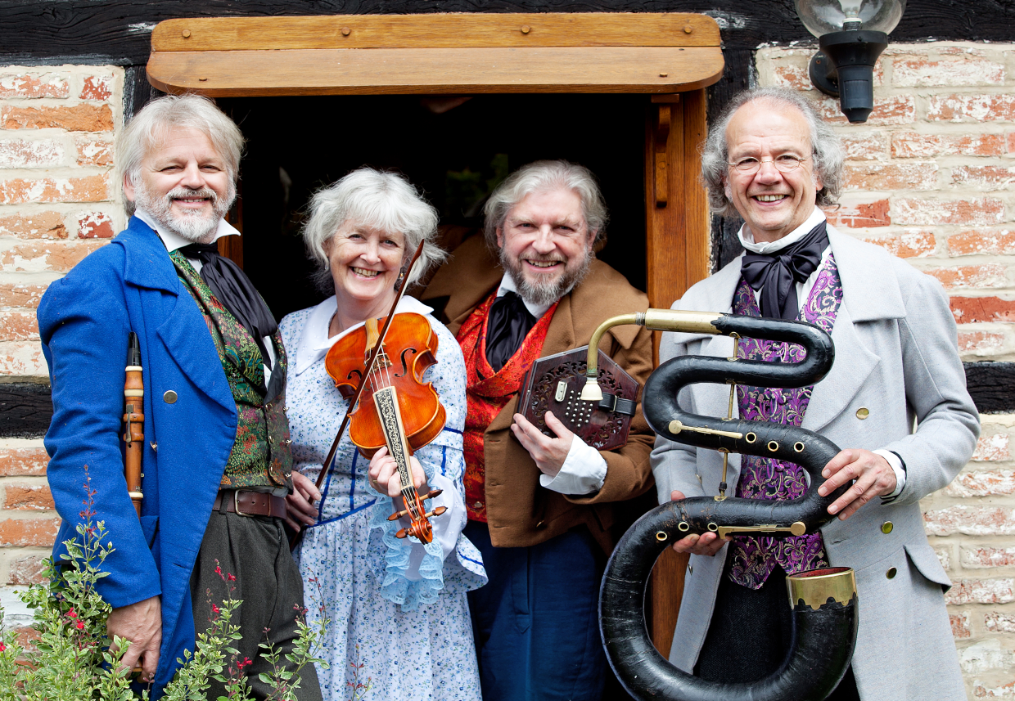

The Band

DaveTownsend
(Director)
Concertina, Voice

Caroline Butler
Violin, Voice

Tim Hill
Clarinets, Voice

Philip Humphries
Serpent, Voice

The popular Mellstock Band is making its third visit to St Mary’s. On the first occasion, in 2002, it was sponsored by the Civic Trust, as the lead concert for the village Queen’s Golden Jubilee Celebrations. They returned in 2006, sponsored by RoDSEC, to give a memorial concert for Mrs Ann Burston, their founding Chairman. This time they have been sponsored, very generously, by Mr Arnold Burston in celebration of his 80th birthday.
Tickets, £10, including refreshments, available from September, from St Marys,
Tom & Sylvia Martin (813320) or Arnold Burston (813457)

