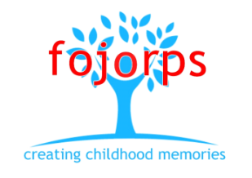
Friends of
John of Rolleston Primary School

FOJORPS has completed another fantastic year, running events that both provide a great experience and supporting the school by raising much needed funding.
With our events now completed, save for our special Leavers’ Disco at which we mark the departure of our top year to pastures new, we are looking forward to a well-earned Summer break!
Once again, the weather was reasonably kind to us for our annual Community Day. Children, parents, friends and the villagers all seemed to have fun, and – despite being a slightly shorter event than in recent time - our takings were again very good. As well as thanking all the visitors, staff, volunteers and Committee Members, we would also like to record out thanks to Barclays Bank and their employees who, through a generous matched funding scheme, helped us to boost our coffers.
All of our events have been well supported this year, from discos, through Christmas and Community Day, and we are thrilled with how the year turned out.
We are, however, looking forward to a Summer off, and will come back to the start of the new academic year in September – with the elections of our new Committee Members – with renewed energy levels.
We would encourage all parents to keep an eye on our newsletter and Facebook pages for the dates of our Annual General Meeting in September
Thank you for your continued support
Russell Copley, Chair of FOJORPS
07976 964881

