Rolleston on Dove

Parish Council

Clerk Mrs J Bucknall
32 The Lawns
www.rollestonondovepc.co.uk Rolleston on Dove
Tel/fax 07400 280561 Burton on Trent
E-mail rollestonpc@outlook.com Staffs. DE13 9DB

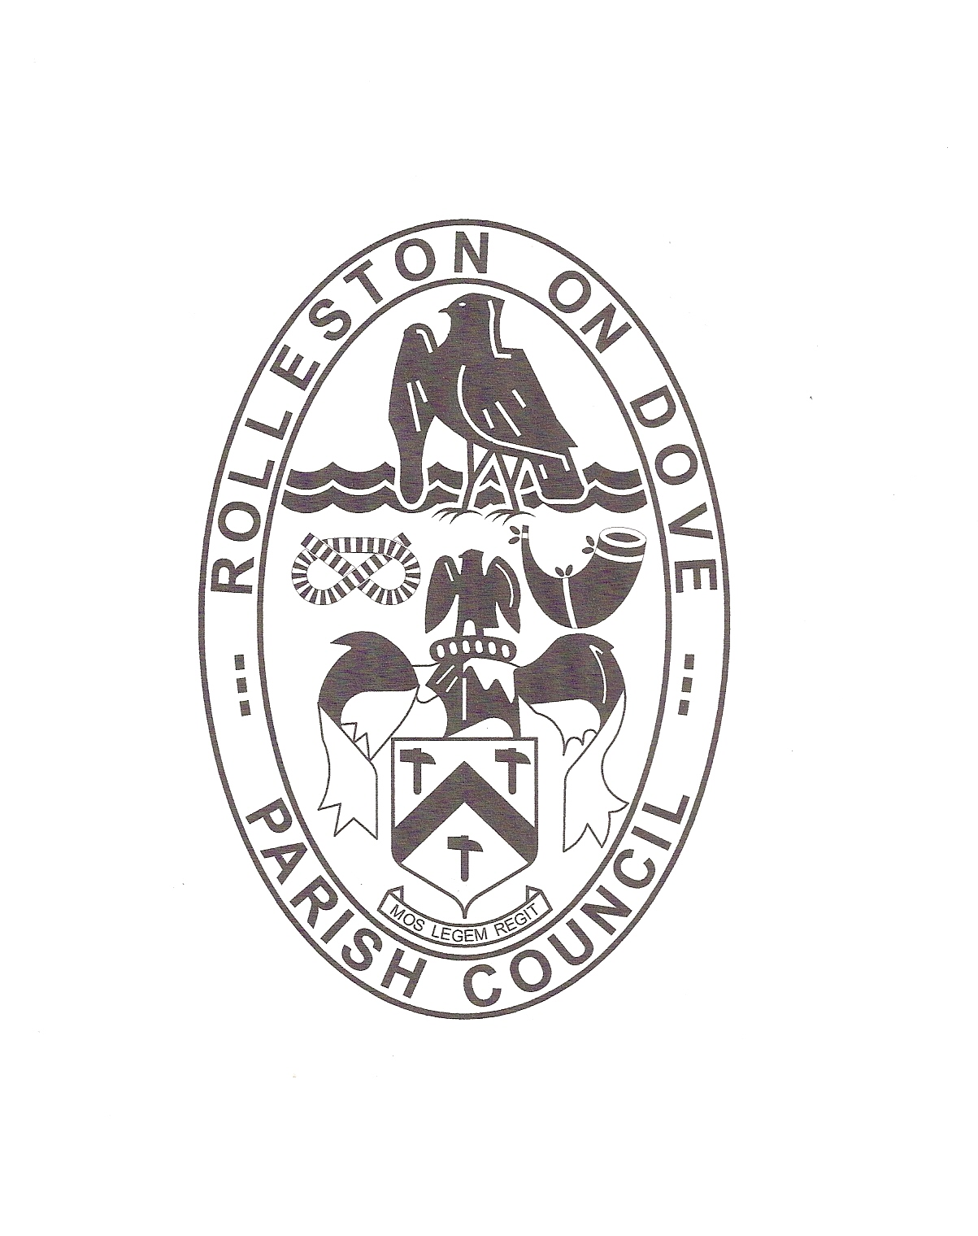

Dear Sir/Madam,

You are summoned to attend a Full Parish Council Meeting on Monday 12th November 2018 in the Old Grammar School rooms, adjacent to St Marys Church, Church Road, Rolleston on Dove, commencing at 7.30pm.

Yours faithfully

J. Bucknall
Clerk
AGENDA
- Public question time and presentation of petitions
- Apologies for absence
- Declarations of interest
- Clerks report
Planning applications
Planning decisions and other planning matters
- Report of County Councillor
- Report of Borough Councillor
- Report of Parish Councillors
- Correspondence received
- Minutes of meeting held 8th October 2018
- Matters arising from minutes of previous meeting
- Neighbourhood Development Plan
- Civic Trust Tree Project
- Almshouses gas installation – use of the Croft
- Best kept village
A full copy of the Agenda, Clerks Report dated November 2018 and minutes of the meeting held on 8th Oct 2018 are available to download from the village website at www.rollestonondovepc.co.uk

- Property level resilience – flooding
- Finance and accounts for payment
- Budget 2019-20
- Items for next agenda

Confidential Items - Members of the Public and Youth Representatives will be requested to leave at this point.

- Quotes

