Chive Plant
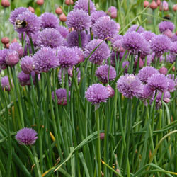

Allium schoenoprasum
Recommended by the RHS to be an excellent attractant and nectar source for bees and other beneficial insects.
- Hardy perennial.
- Evergreen in most climates, but can die back in harsh Winters.
- Cylindrical leaves.
- Mild onion flavour.
- Pink flowers June to August.
- Likes a sunny position but will tolerate shade.
- Likes rich, moist but well drained soil. Will tolerate poorer soils.
- Remove flowers for best flavour, but flowers can be used in salads.
- Split / divide every 3 - 4 years in Spring.
- Can be grown indoors or out.
- Usually reach 12 - 24" (30 - 60 cm) tall.
- Always leave 2" (5 cm) for best re-growth.
- Culinary Uses.
- Flowers can be used in salad.
- Leaves can be used in salad, omelettes, sandwiches, cream cheese and so much more!
- Medicinal Uses.
- Contain mild antibiotics and some iron.
- A source of Vitamin C.
- Can stimulate your appetite
- Can improve your digestion and help with intestinal problems.
- Can be used as a mild laxative.
- Homeopaths use to treat colds and bronchitis.
- Other Uses.
- Can be used to deter aphids and mildew.

