Feverfew
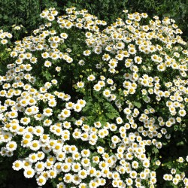
Tanacetum parthenium
- White flowers that resemble daisies from July to September.
- Prefers a full sun position.
- Likes dry, well drained soil.
- Hardy perennial.
- Self seeds.
- Bitter flavour.
- A member of the daisy family.
- Reaches approximately 2 feet (60 cm)high.
- Taste better in a sandwich with marmite!
- Leaves can be frozen.
- Medicinal Uses.
Feverfew can be eaten as the fresh leaf, made into a green leaf tea or dried for later use as a tea.
- Aids melancholy, vertigo, aches and pains.
- Eat a couple of fresh leaves per day to reduce the symptoms of migraines.
- Can aid the soothing of muscle spasms.
- Can be dried and used for tea.
- Can aid more restful sleep.
- Can aid relief for arthritis and rheumatism.
- Can be used as a mouth rinse.
- Mild laxative.
- Tonic for appetite.
- Can ease depression.
- Promotes good digestion.
- The leaves can induce delayed menstruation.
- Washed over the skin or the oil from the leaves can act as an insect repellent.
- The flowers can be used for instant relief from insect bites.
- Can relieve symptoms of hay fever.
- Other Uses.
- Flowers can be used in pot pourri.
- Can be infused to make a mild disinfectant.
- Dried can deter moths!

