Marjoram Plant
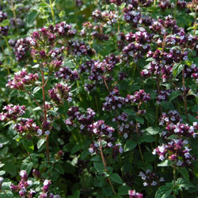

Origanum majorana
Also known as sweet or knotted marjoram.
Sweet pine and citrus flavoured grey green foliage. A very valuable herb as an infusion as it is a relief for stomach pains.
Recommended by the RHS to be an excellent attractant and nectar source for bees and other beneficial insects.
- Tender perennial.
- Reaches 2 feet (60 cm) tall.
- Likes a warm sunny position.
- Likes dry, rocky, free draining soil.
- Suitable for container growing.
- Flowers July - September with small pale pink flowers.
- If you cut plants to 1" (2.5 cm) in Autumn they can be brought indoors.
- Culinary Uses.
- Good for use in stews, soup, on pizza, with pasta, eggs and cheese!
- Can be infused for tea.
- Chopped into salad.
- Can be used in bouquet garni.
- Good compliment for fish.
- Flowers are edible.
- Medicinal Uses.
- Can ease tonsilitus.
- Can help flatulence.
- Can ease stomach bloating.
- Can help sleep or calm children.
- Can ease anxiety.
- Homeopaths sometimes use to treat female sex disorders and painful menstruation.
- Good for bruises.
- Has good antiseptic properties.
- Used to make essential oils.
- Other Uses.
- Used in pot pourri and herb pillows.
- Has been used to scent furniture polish.

