Parsley Plant
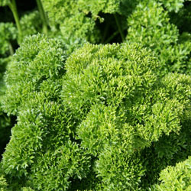

Petroselinum crispum 'Champion Moss Curled'
- Hardy-biennial.
- Reaches 12 - 30" (30 - 80 cm) tall.
- Flowers in long-stalk like green umbels June - July (however if it flowers the leaves become in-edible and the plant will die).
- Likes a rich moist soil.
- Prefers part shade.
- Pick leaves regularly.
- Full of vitamins and minerals (particularly Vitamin C).
- Culinary Uses.
- Often used in soups and stews.
- As decoration for the top of almost any dish!
- Chewing after meals can help freshen breathe (even from garlic).
- Can be added to salad and sandwiches.
- Can be used in bouquet garni.
- Medicinal Uses.
- Can be used to treat urinary infection, kidney stones and water retention problems.
- Can help menstrual problems.
- Can aid digestion, and act as a mild laxative.
- Leaves can be infused and will then act as a tonic for hair, eyes and skin (and said to minimize freckles).
- Crushed leaves have been used as temporary dressings for open wounds.
- Can help irritation caused by insect bites.
- Can alleviate water retention and act as a kidney tonic (and help clear kidney stones)
- Can help improve circulation, arthritis and rheumatic pain.
- Can help relieve asthma and ease any lung congestion.
- Can help milk production in Mothers
- Has been proved to reduce blood pressure.
- Contains antioxidants said to help fight cancer.
- Other Uses.
- Was used to decorate tombs.
- The Romans made garlands from it!
- If grown by roses can help improve their scent.

