Thyme Plant - Common Thyme
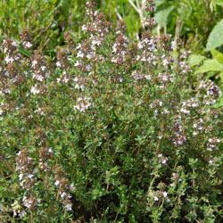

Thymus vulgaris
Recommended by the RHS to be an excellent attractant and nectar source for bees and other beneficial insects.
- Hardy perennial.
- Evergreen.
- Likes full sun.
- Prefers a well drained, light, gravelly alkaline soil.
- Best flavour of the leaves is while the plant is in bloom.
- Can grow as a hedge.
- Reaches 12 - 18" (30 - 45 cm) tall.
- Cut back in mid Summer to keep them bushy.
- Beautiful pinky/mauve flowers from May to October.
- Culinary Uses.
- Used in bouquet garni.
- Excellent for marinades, stuffing, sauces, stews, soup etc.
- Excellent accompaniment to chicken and beef.
- It is used to flavour Benedictine liquer!
- Flowers are edible.
- Medicinal Uses.
- Antiseptic, anti-bacterial and antifungal properties.
- Stimulates circulation.
- Good to prevent spots and dandruff!
- Can aid digestion.
- Said to be good for hangovers!
- Good for convulsive coughs, whooping cough, chronic bronchitis, colds and sore throats.
- Good in massage oil
- Can relieve insomnia.
- Can relax spasms.
- Can ease Asthma, bronchial catarrh and chest infections.
- Good for inflammation, rheumatism and arthritis.
- The oil can ease athlete's foot.
- Can help vaginal thrush.
- Can stimulate production of white blood corpuscles to help resist infection.
- Sometimes used in mouthwash.
- Other Uses.
- Often included in summer posies.
- Good for pot pourri.
- Great to grow to encourage bees and the honey they then produce is delicious.
- Can be used to protect from mould.

