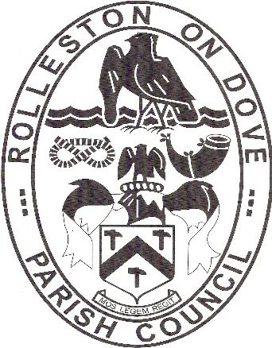

Rolleston on Dove

Parish Council

Clerk: Mary Danby
32 Hillcrest Rise
BURNTWOOD
WS7 4SH

Mobile: 07400 280561 (Office hours)
Email: rollestonpc@outlook.com

Our Ref: MD 03 December 2018

To: All Members of the Parish Council

Dear Councillor

You are hereby summoned to attend a Meeting of the Parish Council Meeting to be held in the Old Grammar School Rooms, adjacent to St Mary’s Church, Church Road, Rolleston on Dove DE13 9BE on Monday 10 December 2018 commencing at 7.30pm at which the business set out below will be transacted.

Yours sincerely
MDanby
Mary Danby
Clerk

PUBLIC FORUM
A maximum of 15 minutes will be allocated prior to the commencement of the meeting when members of the public may put questions/comments on any matter in relation to which the Parish Council has powers or duties which affect the area.

- To receive apologies
- To receive Declarations of Interest
- To receive written applications for dispensations under the Localism Act 2011
- To consider the Minutes of the Council meeting held on 12 November 2018 (Enclosure No. 1)
- To consider matters arising from the previous meeting
- To receive a report from the County Councillor
- To receive a report from the Borough Councillor
- To receive reports from Parish Councillors
- To consider financial matters
- Planning matters
- 2019/20 Budget
- Neighbourhood Plan
- Best Kept Village
- Filling of planters
- Troughs
- RoSPA Report
- List of ongoing items
- To agree a policy regarding the storage of archived council records
- East Staffordshire Borough Council: Consultation: Open Space and Playing Pitch Draft SPD
- Exclusion of the press and public
- Expenditure on property level flood resilience

