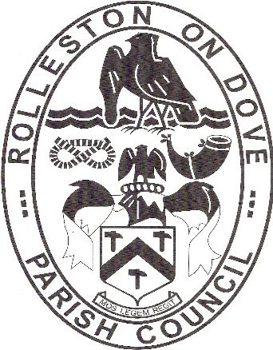

ROLLESTON ON DOVE PARISH COUNCIL

WHO IS RESPONSIBLE FOR WHAT?

An information leaflet
Rolleston on Dove Parish Council offers a range of services within the village. Other councils provide services in Rolleston. These are East Staffordshire Borough Council and Staffordshire County Council. Each council operates separately to focus on a hierarchy of activities but liaise with each other to work effectively.

The Parish Council is the closest to the people as it is the first tier of local government. It provides a voice for Rolleston and looks to provide its services economically and efficiently. Although it only has limited powers, the Parish Council works in partnership with other authorities and agencies to address problems and provide services.

Rolleston on Dove Parish Council provides the following services:

BEST KEPT VILLAGE COMPETITION
Benches
Bus shelters
CHRISTMAS TREES
CONSULTEE on all matters relevant to the village
GRANTS TO VOLUNTARY ORGANISATIONS
NEIGHBOURHOOD DEVELOPMENT PLAN
PLANNING MATTERS (acting as a consultee on planning matters)
PLANTERS
PLAYGROUNDS AND OPEN SPACES
PROMOTING THE VILLAGE
PUBLICITY/INFORMATION:
FACEBOOK
NEWSLETTER
NOTICEBOARDS
WEBSITE
Services provided by East Staffordshire Borough Council include:

Building Regulations
By-laws
Clean Air
Council Tax collection
Environmental Health:
Food safety and hygiene
Grants for various activities
Home Safety
Housing
Local Licensing
Markets and fairs
Museums
Overgrown hedges/vegetation obstructing pavements/footways
Pavement sweeping
Planning:
Advertisement Control
Building Preservation Notices
Conservation Areas
Development Control
Listed Building Control
Local Development Framework
Tree Preservation
Recreational Facilities
Refuse Collection
Transportation:
Community Transport
Off-street Parking

Services provided by Staffordshire County Council include:

Children and Lifelong Learning
Consumer Protection, e.g.:
Food and Drugs
Trades Description
Weights and Measures
Fire & Rescue Service
Flood prevention
Footpaths and Bridleways
Libraries
Museums and Art Galleries
Planning:
Local Development Framework
Minerals and Waste Policies
Police
Refuse Disposal
Social Care and Health
Transportation:
Footway Lighting
Drains / gullies
Highways
Highways Lighting
Public Transport
Road Safety
Transport Planning
Youth Services

For further information contact:

Rolleston on Dove Parish Council
Tel: 07400 280561 (Office hours)
Email: rollestonpc@outlook.com
https://rollestonondovepc.co.uk

