Rolleston on Dove Village Clean-Up
Saturday 16th March, 9am-12noon
Meet on the Croft
Tasks
- Clear brook debris and litter
- Remove ivy and weeds from banks of Brook
- Litter pick
Bring tools and gloves for weeding, snipping, pruning and clearing

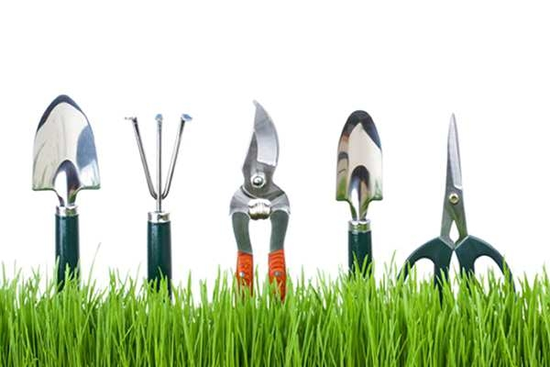
For more information call Mary 07400 280561, or speak to any Parish Councillor
Help Rolleston look like the best kept village in the area

