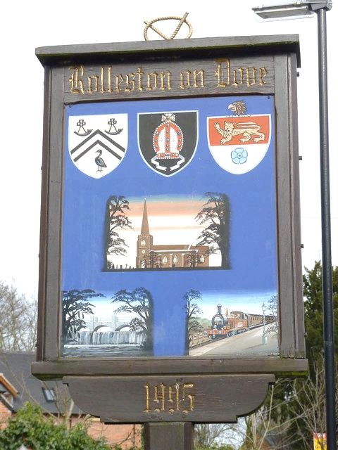

Submit your Rollestonian of the Year nomination in writing, via email, messenger, text or note in the box in Starbucks or The Club, or through the door of

“Hilltop”, South Hill

[rollestonpc@outlook.com](mailto:rollestonpc@outlook.com)

07400 280561

**Closing date for nominations:**

**Friday 31st May**

This year’s winner will have their name on the new Roll of Honour Board, joining past winners, an engraved keepsake, two tickets to Rollestonbury

