World War I Commemoration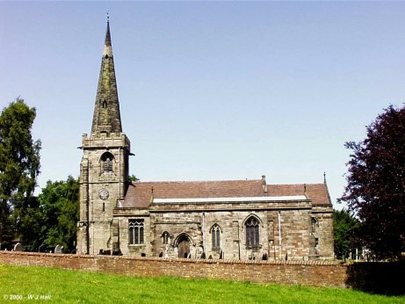
Private Albert Rusconi
1st/4th Battalion King’s Own (Royal Lancaster) Regiment
16th April, 1919
Private Albert Rusconi died on 16th April 1919, aged 33, from injuries sustained on the Ypres Salient, where he was wounded by machine gun fire, after seven months serving in France and Belgium.
The local press reported in March 1919 that Albert had now been invalided home, with serious wounds which had prevented an earlier return to England. He had septic poisoning of the arm, which would not heal, underwent seven operations, and contracted influenza and pneumonia. After appearing to rally, and following a visit from his wife during which he is described as being “cheerful”, he suddenly relapsed, and died a few days later.
The press report following Private Rusconi’s death stated that he was “…much respected at Rolleston…” and offered condolences to his widow and two children.
Following a service at Rolleston church, Albert was buried in an “…interment … of a military character…”, at Stapenhill Cemetery, where his parents James and Mary, who had pre-deceased him, were already at rest. His wife Florence, as well as his brother Frederick, would later join him in the family grave, in 1970 and 1969 respectively.
(Information taken from The Lych Gate War Memorial, by Arnold Burston.)
The bells of St Mary’s Church, Rolleston, will be rung half-muffled for Evensong, from around 5.15pm on Sunday 7th April 2019, in memory of Private Albert Rusconi, the final local casualty from Rolleston-on Dove of the devastating conflict of World War One.

