Jubilee Orchard 2 MR 1.18
Rolleston on Dove Jubilee Orchard.
How do the trees produce fruit?
In our Jubilee Orchard we have 44 trees that produce Plums, Cherries, Pears and three species of Apples.
The trees produce flowers in the spring, but these flowers must be pollinated if they are going to turn in to fruit.
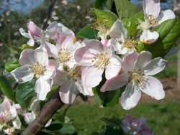
Pollination of fruit trees entails the transfer of pollen from the male part of the flower, the stamens, to the female part, the stigma and then to the ovule where the two parts fuse and fertilisation takes place. This happens naturally by bees and other pollinating insects such as hoverflies.
However we can give nature a helping hand by considering a couple of things.
- Some fruit trees are self fertile – this means they can pollinate themselves, this includes some plums, some cherries, but very few apples. However they will always pollinate better if grown with other fruit trees where cross pollination can take place.
- Bear in mind that apples pollinate apples and not other fruit tree species such as pears. The same goes for plums, etc. So for successful cross pollination other fruit trees of the same type must be growing nearby and the flowers need to be flowering at the same time.
Each fertilised ovule becomes a seed and the rest of the flower develops in to a fruit.
If the flower is not pollinated it dies and no fruit will develop.
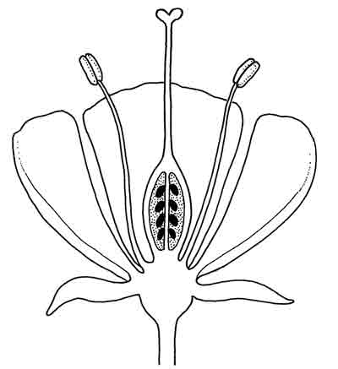
Draw label lines from the diagram to the words:
stamen
stigma
ovule

Can you also label the petal, sepal, style and ovary?
What is a pollen tube?

