Jubilee Orchard 3 MR 1.18
Rolleston on Dove Jubilee Orchard.
Are new apple trees grown from seed?
Apple trees do NOT produce "true to seed" That is, if you plant a seed from a Braeburn apple, you will NOT get a tree that produces Braeburn apples. It is generally understood that the chances of getting a "delicious" apple from a seed are approximately one in ten thousand (1:10,000).
Apples, like most living things, are genetically diverse. Pollen from one plant fertilises the ovule from another plant, so the seed will grow into a plant that is a mixture of both. In the same way as you are not identical to your father or your mother, but you have characteristics from both of them.
If you want to grow a Braeburn apple (or Conference pear, Sunburst cherry, etc) you have to find someone with a Braeburn apple tree, get some ‘scion wood’ from that tree and ‘graft’ it onto your seedling. This is the only way to get the variety of fruit you prefer.
The purpose of grafting is to combine one plant's qualities of fruiting with the roots of another that offers vigour and resilience. This is a difficult task and requires lots of skill and practice.
In most cases, fruit trees are bought already grafted onto a rootstock.
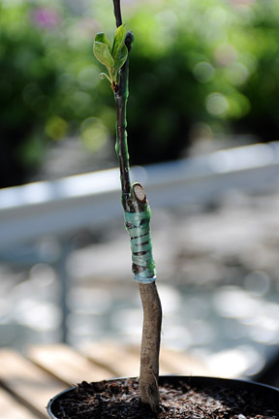
Look carefully at some of the trees in our Orchard. On the trunk of the tree, just above the ground you may still be able to see the ‘scar’ where the graft was made. When planting fruit trees it is important that this scar is above the ground or the scion wood might form its own roots, which will not be as good as the selected rootstock.
Did you realise that every Braeburn apple or Conference pear tree in the world is actually formed from cuttings taken originally from just one tree. This is called ‘propagation’

