Braeburn Apples

Malus domestica 'Braeburn'

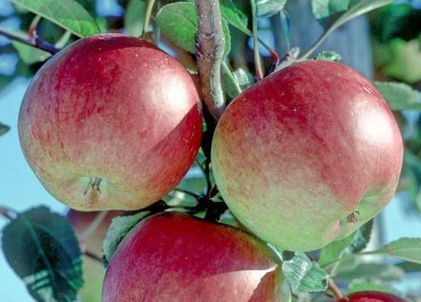
Braeburn is one of the most important commercial apple varieties, grown in all the major warm-climate apple producing areas of the world. It has a very good flavour when grown in the right conditions and stores extremely well.
There are numerous different sports or clones of Braeburn - these arise as natural mutations and are favoured by commercial growers because they usually more highly coloured in areas with less sunshine such as the UK. The best-known in the UK are 'Mariri Red', 'Helena' and 'Hillwell'.
Braeburn apples, botanically classified as part of the Rosaceae family, were first discovered in the Braeburn Orchard in New Zealand in 1952 as a ‘chance seedling’ .It was then spread to warm regions around the world and has become a popular commercial variety. Braeburn apples can be found growing and sold at specialty markets in New Zealand, Chile, France, Italy, England, and United States.
. They are a ‘chance seedling’, which means they were not bred intentionally but were created by nature. The exact parentage of Braeburn apples is unknown, but they are believed to be a relative of the Lady Hamilton and Granny Smith apple, both varieties which were growing in the orchard where the Braeburn apple was first discovered.
Braeburn apples are a modern variety that is known as an all-purpose apple and are valued for their strong flavor that rivals the classic apple cultivars.

Braeburn apples represent a new era of apple cultivation as they are one of the first modern varieties created that can match the strong flavors of the classic apple cultivars.
Braeburn apples are a good source of fiber, vitamins A, and C, and contain trace amounts of boron and potassium, most of which are located in the apple's skin.
Braeburn apples are best suited for both raw and cooked applications such as baking and roasting. When raw, the apples can be sliced and added to salads and sandwiches or served on a cheese board or fruit platter. The sweet-tart flavor of the Braeburn apple mellows just slightly when cooked and will compliment both sweet and savory preparations. They can be roasted along with root vegetables, sautéed and served atop pork, or slow cooked and pureed to make sauces, jams, and preserves. Braeburn apples hold their shape well when cooked. They can be baked into pies, crisps, tarts, cakes, and galettes or hollowed and stuffed to make baked apples. Chopped Braeburn apples will also add sweetness and texture to bread, pancakes, and muffins. Braeburn apples pair well with cheese such as gouda and camembert, cinnamon, and salted caramel. They will keep up to a month when stored in the refrigerator.
Braeburn is generally an easy variety to grow, but it needs a long growing season. It is particularly well-suited to the intense sunlight of the southern hemisphere. It should be successful in the southern UK and does very well in France and Italy. The tree will grow quite happily further north, but the apples may not ripen in a shorter growing season.
It is self-fertile and does not necessarily need a pollination partner to produce apples and is a good pollinator for other varieties that flower at the same time.

Pick: Very late-season (mid-November)
Flowering group: 4
Self-fertile
Uses: Eat fresh
Picking season: Very late October / early November?
Use / keeping: 3 months or more?
Flavour quality: Good?
Flavour style: Aromatic
Good for eating fresh

