Bramley (Cooking) Apple

Malus domestica
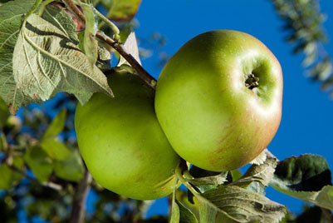

The first Bramley tree was raised from a pip by a young girl, Mary Ann Brailsford, near Nottingham in 1809. The house, with the mature tree in the garden, was later sold to a Matthew Bramley who allowed cuttings to be propagated. The original tree, now more than 200 years old, still survives.

The new variety was quickly recognised as an outstanding cooking apple and by the end of the Victorian era it was widely planted in England and Northern Ireland, becoming synonymous with English apple cookery. However, for the next century it remained little-known outside the UK, since European and North American growers had long preferred dual-purpose apples which could be both eaten fresh and cooked.

Bramley's Seedling is the definitive English "cooker" - an apple variety used mainly for cooking purposes (although many people like to eat them fresh as well).
Bramley is well-known for its rich sharp acidity - it has one of the highest acid contents of any apple variety. As a result, it cooks down to a stiff but light apple puree, a key requirement for English apple cookery, with an excellent sharp flavour.
The copious juice makes Bramley's Seedling valuable for juicing as well, and the juice can also be used in cider production.
Bramley apples in shops are often a solid green colour, this is because they are usually picked a bit early for long-term cold storage.
Bramley's Seedling is a very vigorous triploid variety - it has three sets of chromosomes rather than the more usual two. Its triploid nature can be seen in the strong dark-coloured leaves, thick branches, and large apples. Bramley's Seedling is quite easy to grow, its great vigour and natural disease resistance means it usually throws off problems fairly easily.
A particular characteristic of Bramley is that it tends not to produce side-shoots when it is young, and a 1-year Bramley tree will often resemble a stick with no side-shoots at all. Cutting the stem back after planting will help, but do not worry if your new Bramley tree takes a year or two to start looking like a tree.
As a triploid variety, Bramley's Seedling is not able to pollinate other apple varieties, but ironically it has attractive and prolific pink-flushed blossom. The fruit ripens late in the season and stores very well.

