Cox’s Orange Pippin Apple

Malus domestica
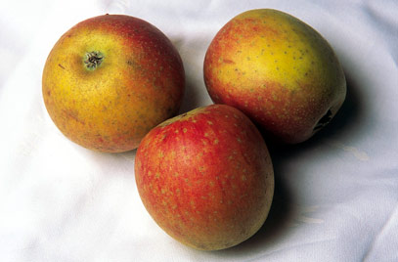
Family Rosaceae
Genus Malus are small to medium-sized deciduous trees with showy flowers in spring and ornamental or edible fruit in autumn; some have good autumn foliage colour
Details 'Cox's Orange Pippin' is a desert cultivar in pollination group 3. It needs favourable soil and weather conditions to crop well. Fruit is medium-size with an orange/red flush and red stripes over greenish-yellow, with a rich flavour. Season of use is from October to January
Propagation Propagate by chip budding or grafting onto a clonal rootstock for fruit. The rootstock used will largely determine the size of the tree
Pruning Regular pruning is required
Light green to yellow in colour, the Pippin apple is oftentimes splashed with orange and red russetted highlights. Its creamy white flesh is crisp, juicy and aromatic. When first picked the taste of the Pippin has a rich sweet tart apple taste with nuances of spice and pine, a flavour that will pleasantly mellow in cold storage.
The Pippin apple is said to have originated as a chance seedling or “pip” near a swamp estate of Gersham Moore, in Newtown, Queens County, New York in 1730. One of the oldest apple varieties of the United Sates, the Pippin is said to have been a favourite of Thomas Jefferson, George Washington and Ben Franklin. In the 1800’s the Pippin was exported to London where it was also a favourite of Queen Victoria. Today the bulk of commercial Pippin apple supply comes out of California, Washington State and Oregon with a smaller supply coming from New York and Virginia

Pippin apples are a good source of soluble fibre, which has been proven to help lower cholesterol, control weight and regulate blood sugar. They also contain vitamins A and C, as well as a trace amount of boron and potassium, most of which is located in the apples skin.
An excellent cooking apple the firm flesh of the Pippin is perfect for use in pies, tarts and turnovers. Sliced or cubed Pippin will add sweetness and moisture to cakes, breads and muffins. They can be slow cooked to make apple butter and preserves or pureed to make soups and sauces. Their slightly spicy flavour makes them a popular apple for use in juice and cider. Since they are quick to brown when cut, for fresh preparations the Pippin is best used shortly after slicing. Its flavour pairs well with orange, clove, cranberry, nutmeg, walnuts, dates, almonds, apricots, gorgonzola cheese and thyme.

