Blackberry

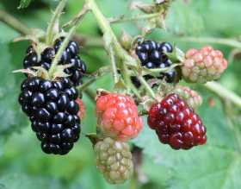

The humble blackberry has much to offer, it is high in vitamin C, crops heavily, is easy care, can be eaten fresh or cooked, and blends very well with apples for jams, crumbles and other side dishes.
Blackberries, as well as most blackberry hybrids, can be vigorous growers to the point of being rampant if not kept regularly in check with heavy pruning. Once established, blackberries are good croppers even in poor soil conditions.

Recommended Varieties
- Cultivated plants generally produce larger fruit and crop more vigorously than their wild cousins.
- All blackberries can suffer from mildew. Good airflow by pruning helps to prevent this.

Sowing & Growing
- They are self-fertile so you’d need only one plant. Each flower makes one berry.
- Bare-rooted blackberries are best planted during their dormant season in November-December before the ground becomes frozen or too wet.
- Full sun is an ideal location
- Along fences is ideal to better deal with the vigorous growth. Wherever a cane touches the ground, it will immediately root.
- The fruit develops on one-year-old canes (shoots). Tie the shoots to wires to keep them easy to crop, to make pruning easier and to ensure a good flow of air around the fruit.
- An easy method of training the fruit is a sort of alternating cordon method; train this years’ canes to one side, the next year’s growth on the other side. After fruiting, the first side is cut off at ground level. In this way the fruiting side alternates each year.
- Ready towards the end of summer into early autumn. Pick when the fruits are soft, sweet and a dark colour. Avoid picking the red ones that are still too tart.

- Picked berries must be refrigerated immediately and will keep only a few days. They also freeze very well individually on a baking sheet and when frozen packed into freezer bags

