Blackcurrants

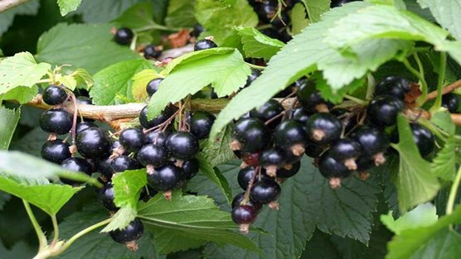
Blackcurrants are easy to grow, producing bunches of dark purple berries in mid-summer, rich in vitamin C. With their tart flavour they can be made into pies and jams, cordials and even cassis.
Place a mulch (such as well-rotted manure or mushroom compost) around the plants to suppress weeds.
Avoid hoeing near the base of bushes because the hoe might cut through new shoots developing at the base.
Water blackcurrants during dry periods in the growing season.
Prune blackcurrants when dormant – from late autumn to late winter. They fruit best on younger wood, so when pruning aim to remove older wood, leaving the younger branches.
Up to and including the fourth year after planting, remove weak, wispy shoots, retaining a basic structure of 6 to 10 healthy shoots.
In year four, cut out about one-third of the older wood at the base, using a pair of loppers or a pruning saw. This will encourage and make room for younger, healthy wood. Also remove weak shoots and low ones leaning towards the ground.

Blackcurrants tolerate a wide range of soil conditions, but prefer well-drained, moisture-retentive sites. They prefer full sun but will tolerate light shade.
Harvest the fruit on modern varieties such as the ‘Ben Sarek’, ‘Ben Hope’, ‘Ben Lomond’ and ‘Ben Connan’ by cutting the strigs (bunches of fruit) as they turn black. Older types of blackcurrant varieties ripen at different times, with the currants at the top of the strig ripening first. The fruit should therefore be picked individually.
Eat fresh blackcurrants within a few days of harvesting. Alternatively, they can be frozen, cooked, or made into smoothies, jam or jelly.
