Blueberry
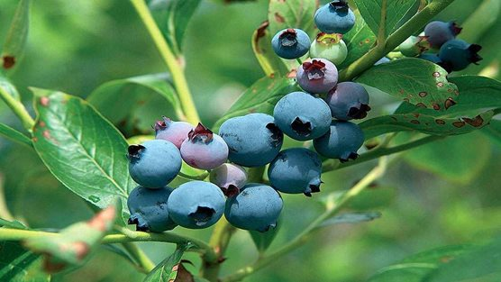
Not only are blueberries productive, their glorious autumn colours provide ornamental appeal. The fruit is delicious and high in antioxidants.
Blueberries are relatively easy to look after. Keep the compost or soil moist, but not soaking wet. Don’t allow it to dry out.
You may find open ground plants don't need feeding apart from the annual ericaceous mulch and a high nitrogen feed such as sulphate of ammonia in late winter. Blueberries are sensitive to overfeeding.
Pruning is rarely needed in the first two years. After that you should prune in late February to early March. Once you start pruning, you should aim to remove a quarter of old wood at the base every year to keep the plant productive.
Blueberries are very fussy about soil acidity. They will not grow well if planted in alkaline soil.
If growing blueberries in garden soil, add plenty of bulky, acidic organic matter such as pine needles, leaf mould or composted conifer clippings. Avoid well-rotted farmyard manure as this is too rich and alkaline.
Fruits start to ripen from mid-summer onwards, changing colour from green to dusty blue. At this point they can be harvested.
Pick over the plants several times as not all the fruit ripens at the once.
Berries can be eaten fresh; alternatively, they can be dried, frozen, made into preserves, or used in cooking. They are extremely rich in antioxidants and vitamins (especially vitamin C) so have many health benefits.
