Cherry (sweet) 'Sunburst'

Prunus avium

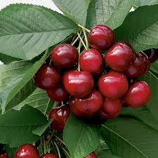

Sunburst was developed by the Summerland research station in British Columbia, Canada and released in 1965. It is a cross between Van and Stella.
Genus Prunus can be deciduous or evergreen trees or shrubs with showy flowers in spring, and often good autumn foliage colour. Some have edible fruit in autumn, and a few species have ornamental bark

'Sunburst' is a self-fertile cherry with large, sweet, very dark red fruit in midsummer, white spring blossom and good autumn colour
- Propagation Propagate by chip budding or grafting on clonal rootstock for fruit

Pruning Train fan-trained trees in spring. Prune established fans and carry out routine pruning on established cherry trees when harvesting the fruits in summer
- Pick: Mid-season (late July)
- Flowering group: 4
- Self-fertile
- Uses: Eat fresh
Sunburst is a good modern self-fertile cherry variety, with delicate flesh, and a good sweet mild cherry flavour. It is also easy to pick the large fruits.
It can be considered an improved version of the popular Stella cherry, to which it is closely related and shares many of its good qualities.
.
Bottom of Form

