Comfrey
Symphytum officinale

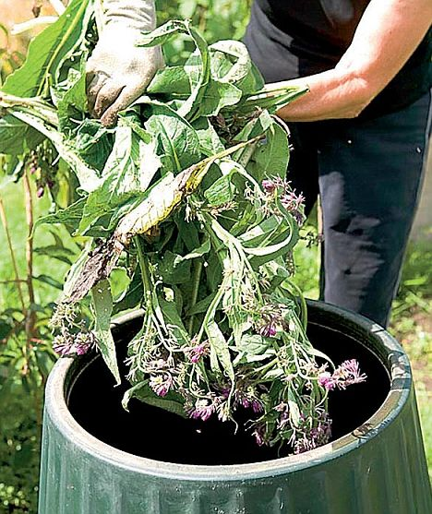
Comfrey enriches the compost heap and encourages decomposition
Therapeutic use of comfrey is limited because of its toxicity.
Comfrey has been cultivated as a green vegetable and has been used as an herbal medicine for more than 2,000 years. Comfrey's original name, knitbone, derives from the external use of poultices of its leaves and roots to heal burns, sprains, swelling, and bruises. Commercial comfrey sale and distribution is restricted in Germany and Canada because of its substantial toxicity.

Use as a fertiliser.
Comfrey is perhaps the most efficient of all British plants at sucking up nutrients. Its deep roots - 10ft or more - take in all available goodness and store it in the large, hairy leaves.
When cut, these break down very fast, so transferring the nutrients back into the soil.
Comfrey can be used in three ways.
The first is simply to add it to the compost heap, where its nutrients will both enrich the whole heap and encourage decomposition. Comfrey has a high carbon to nitrogen ratio - ideal for most plants.
The second way is to spread the leaves as a mulch beneath, say, your tomatoes. This acts like any other mulch - slowing down evaporation of moisture and suppressing weeds - but because the leaves rot quickly, it also enriches the soil where the surface roots are.
As a bonus, as comfrey leaves wilt, they become irresistible to slugs and snails. Strew them around young plants such as lettuce to distract slugs and snails.
Comfrey can also be made into a liquid feed. To do this, fill a container with as many comfrey leaves as it will contain, and top it up to overflowing with water. The leaves soon turn into a repulsive-smelling sludge. But this vile stench indicates that the proteins - and comfrey has more protein in its leaves than any other plant - are breaking down.
After two weeks the mixture will be like greeny-brown soup and ready for use. Strain it through a fairly fine mesh such as a garden sieve, then put the sludge onto the compost heap and use the liquid as the base for home-made fertiliser. Keep it well diluted - 1:10 is about right. You can use it either as a leaf feed or feed it directly to the roots.

