Garlic

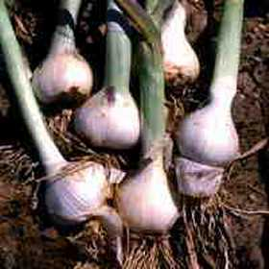

Garlic is a member of the onion family – the Alliums. It can be grown successfully in this country.
WARNING - garlic bought in the supermarket is likely to have been grown in China or Spain, where the climate is completely different and will not be certified disease free for planting.
You can, save home-grown garlic to plant next year if you want to save some money.
Select the best bulbs and use larger cloves for the best results.
Garlic comes in two main types, hardneck and softneck, the hardneck does not store as well as the softneck. There are many different tastes and varieties to try from the seed merchants and garden centres, all certified stock.
After planting, garlic needs a period of cold weather for good bulb development. Planting in late autumn or in early spring, depending on the variety, will provide the necessary cold period.
As the garlic is going to be sitting in the ground all winter, you can get losses due to rot. A well-drained and cultivated soil will give the best results.
Break the garlic bulb into cloves, being careful not to damage them, and plant pointed side up, in holes about 5cm (2ins) deep and 20cm (8 ins) apart. Cover with soil and forget about them until spring.
Hardneck garlic sometimes grows a flower spike or scape. Snip this off as soon as possible. These are actually quite nice snipped up small and used in a salad or stir-fried. If you leave them, the plant puts energy into seed rather than fattening the cloves.
The bulbs are harvested when the leaves begin turning yellow in midsummer.
Allow them to dry off in an airy place, until the foliage is crisp.

