Gooseberry

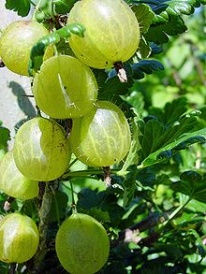

Gooseberries are often thought to be easy to grow but they really need care to produce plants that will bear a good crop of easily pickable berries each year. They are not a popular as they used to be in the 19th century when gooseberry clubs and shows abounded. But they are making a comeback.
Gooseberries are well worth growing for their excellent flavour. Desert varieties are sweet and flavoursome served with cream and sugar or fresh in many dessert and gateaux recipes. Culinary varieties make delicious cooked desserts, jams and preserves and are a good accompaniment for duck.
- Birds, particularly bullfinches often peck out the buds of gooseberries during the winter.
- They should be cultivated in the same way as blackcurrants . They like a rich moist soil so don’t let them dry out and water regularly. Irregular or heavy watering after the plants have dried out can cause the fruits to split. Mulching with well-rotted manure or compost will help to retain food and moisture in the soil.
- Gooseberries fruit on a permanent framework of branches and should be prune in winter in the same way as redcurrants. Prune them into a cup shape with and open centre, this helps to prevent mildew and makes the fruit easier to pick. Remove any lower branches that will reach the soil when loaded with fruit. In the summer prune back the side shoots to about five leaves. This lets in light and air and encourages fruiting spurs to develop.

Gooseberries are slow to ripen, sharp when small and young, sweet when mature. These immature fruits are excellent for pies, crumbles and tarts. Leave the remaining fruits to swell and ripen fully for eating fresh. Not all fruits will ripen at once so pick them over a few times taking those that are well coloured and yield to a gentle squeeze.
- Gooseberries freeze well then, they can be used throughout the year.

- They have a high pectin content which makes the very good for making delicious jam, especially nice if you add some elderflower cordial near the end of the cooking time.

