Great Mullein
Verbascum thapsus
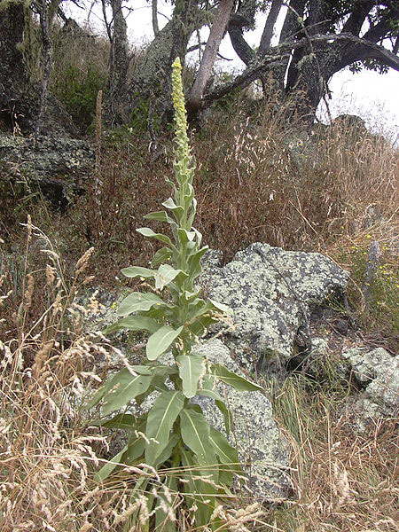
Other Common Names: Common mullein, Aaron’s rod, Adam’s flannel, feltwort, Jacob’s staff, old man’s flannel, blanket leaf, bullock’s lungwort, cow’s lungwort, hare’s beard, lady’s foxglove, ice leaf, Peter’s staff, shepherd’s club, candlewick, flannel leaf, flannel mullein, flannel plant, hedge taper, Indian tobacco, Jupiter’s staff, torch-wort, velvet dock.
The mullein plant can grow to a height of about 7 feet with leaves that grow as large as 50 cm long. The pale gray leaves are covered with silver and felt like hairs.
The flowers are yellow by nature and occupy approximately half of the stem.
Mullein flowers from November through March and is considered by many agricultural businesses to be a weed and more of a nuisance than anything.
It is the mullein leaves and flowers that are used medicinally.
Fresh mullein leaves are also used for the purpose of making a homeopathic tincture. Oil is made from the leaves and flower for medical purposes.
Its uses can be traced back to the Greek herbalist, Dioscorides, who was one of the first to recommend it for in curing a variety of lung diseases.
Various Native American tribes used great mullein to help cure chest diseases.
Great mullein has a very long history as an herbal remedy and in the Middle Ages was regarded as a cure-all. Its focus is that of curing cough and sore throats.
Mullein contains antiseptic agents and is mostly used today for chest ailments including bronchitis, asthma, pneumonia, pleurisy and whooping cough.

