Jostaberry

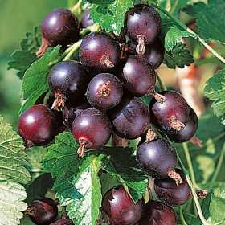

Jostaberry is a cross between a blackcurrant and gooseberries. It forms a very vigorous spineless shrub, growing up to 1.8-2m tall and a similar size across, and is self-fertile
The fruits are larger than a blackcurrant and are dark reddish black in colour. These are more like a gooseberry when slightly unripe, but similar to a sweetish blackcurrant when fully ripe in late July, early August.
- They thrive in moisture retentive fertile soil in full sun, although they will tolerate shade for part of the day.
- Fruit is borne on wood that is one, two or more years old.
- Bushes should be pruned to create an open framework of upright branches. About half of the new growth each year should be removed, and any older, less productive branches or those growing at odd angles should be cut out cleanly just above ground level.

Harvesting, Eating & Storing Jostaberries
Jostaberries are easy to harvest and can be picked individually to avoid damaging the fruits.
They freeze well and can be defrosted to use in the same way as fresh fruits.
Very ripe fruits are sweet enough to eat fresh with cream, or as part of a mixed fruit salad, where their dark colour provides contrast. Cooked, they can be used as pie filling, for crumble or fruit fool, or for jam making.

