Mint Plant - Garden Mint

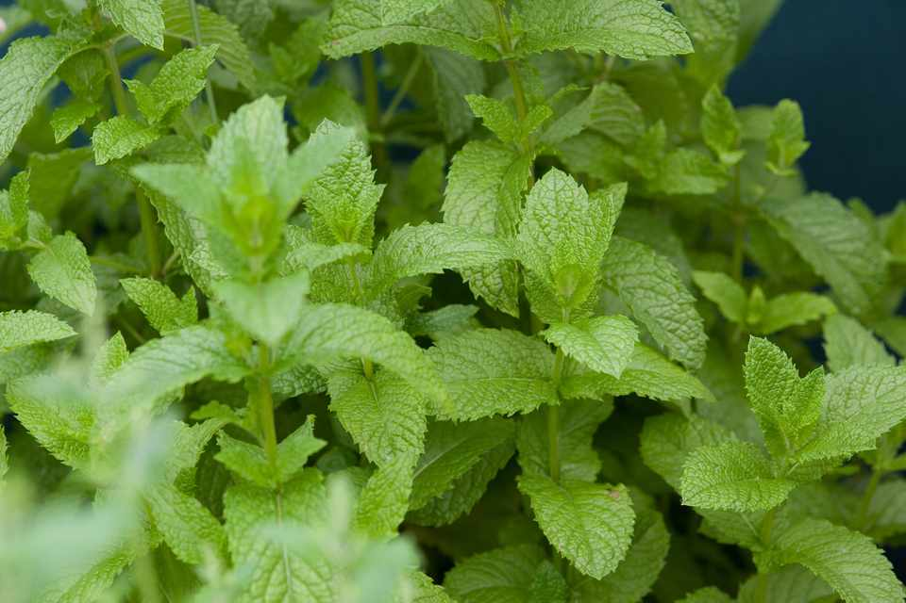
Mentha sachalinensis
Garden Mint is a versatile herb and always worth finding a place for in the garden
Garden Mint has aromatic bright green foliage and small purplish flowers.
Garden mint is a popular choice, especially if you want to use it for cooking as it is fast growing (but don't allow it to dry out during the Summer).
Use it to make mint sauce, the traditional accompaniment for lamb, or to flavour herb jellies. A sprig of mint adds extra flavour to new potatoes or fresh garden peas. Leaves can be infused to make tea, or can be crushed and added to iced drinks.
Mint is also a vital ingredient of the mojito.
Recognised to be an excellent attractant and nectar source for bees and other beneficial insects.
- Hardy perennial.
- Grows up to 3½ feet (100 cm) in height.
- Happy in sun or partial shade.
- Can be invasive so plant in containers.
- Cut back in summer for second flush of growth.
- Highly aromatic.
- Attractive to butterflies, bees and beneficial insects.
- Culinary Uses
- Leaves can be used to make mint sauce.
- Used for flavouring jelly.
- Delicious chopped and sprinkled on new potatoes.
- Leaves can be infused to make mint tea.
- Other Uses
- Said to aid digestion.
- Used to flavour toothpaste and confectionary.
- Good for tea.
