Oregano Plant
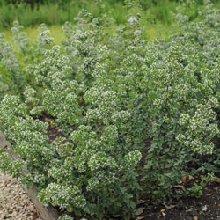

Origanum vulgare

Recommended by the RHS to be an excellent attractant and nectar source for bees and other beneficial insects.
- Perennial.
- Reaches 20" (50 cm) tall.
- Flowers July - October with pink flowers.
- Likes full sun and mid-day shade.
- Prefers well drained, alkaline soil.
- Culinary Uses.
- Can be used in salad.
- Makes a tasty jelly!
- Good for herbal tea.
- Used to be used to flavour ale.
- Good on pizzas.
- Nice mixed with garlic and chilli.
- Compliments haddock.
- Medicinal Uses.
- Good for helping bad coughs and whooping cough.
- Used to treat intestinal problems.
- Can stimulate appetite.
- Can ease diarrhoea.
- Can help gall bladder problems.
- Can ease nervous headaches.
- Can help general exhaustion, irritability and menstrual pain.
- Can be drunk as a sedative to help sea sickness.
- Can help swelling, stiff necks and rheumatism.
- Leaves can relieve toothache.
- Other Uses.
- Used to scent the Greeks bath.
- Used in bouquet garni.
- Can be used as a hair conditioner.

