Conference Pear Pyrus communis

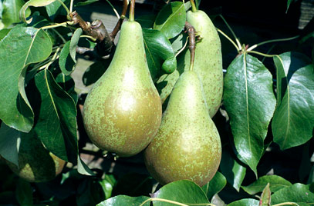

Conference was developed by the Rivers Nursery of Sawbridgeworth, Hertfordshire, in the second half of the 19th century. It is thought to be a seedling of a continental variety called Van Mons Leon Leclerc.
It was named after the National British Pear Conference held in 1885.
Conference is the most widely-grown pear variety in the UK. It crops heavily and reliably and will grow in most situations.
The skin is usually partially covered in golden-green russet.
A home-grown Conference pear, picked just before it is fully ripe, has an excellent flavour that should not disappoint.

Genus Pyrus are deciduous trees or shrubs with oval leaves and scented white flowers in spring, followed by green or brown fruits, edible in some species
Details 'Conference' is a dessert pear, 2.5-8m tall depending upon the rootstock. Flowers white, fruit green. Pollination group 3; can set fruit without being pollinated. Season of use: October to November

Pollination guide for Conference. Conference is in flowering group 3. Conference is self-fertile and does not need a pollination partner, although fruiting may be improved if there is a compatible tree of a different variety nearby. Since it flowers in the middle of the blossom season it can be pollinated by most other pear trees.

Flowers early and so at risk from spring frosts. Can set fruit without pollination but tends to fruit better if cross pollinated by another cultivar. Keep a weed free area of 60cm radius around the trunk. Fruit thinning may be needed
Propagation Propagate by grafting or chip budding onto a clonal rootstock for fruit; quince rootstocks are usually used. The rootstock used largely determine the size
Pruning Regular pruning required; a spur bearer

