Plum 'Victoria'

Prunus domestica
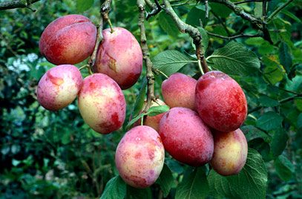
Victoria is by far the most popular plum variety in the UK, dating from the Victorian era, and well-known for heavy crops of very attractive plum-coloured fruit.
Victoria really excels as a culinary plum. It cooks to a distinctive pink/orange puree which makes a very good jam and a good-flavoured filling for pies and crumbles. The stone is semi-clinging, and easy to remove from the flesh. The flavour has a good sweet/sharp balance, and there is often a note of almond in the background which is a characteristic of Victoria.
Victoria plums are sometimes considered inferior to other dessert plum varieties for eating fresh. However, this assumption is probably based on the poor flavour of shop-bought Victoria plums, which are usually picked far too early. The plums will ripen over a period of several weeks and if you want to eat them rather than cook with them, leave the plums on the tree until they are fully ripe - the skins will start to become a darker red /purple rather than the more usual orange flushed colour. At this point the flavour will certainly not disappoint.
This combination of excellent culinary qualities along with good flavour for eating fresh makes Victoria one of the most versatile plum varieties for the UK grower.
'Victoria' is a reliably fruiting, self-fertile dessert and culinary plum to 2.5-4m in height depending upon the rootstock. Flowers white, dark red fruit in August-September
- Ultimate height 2.5-4 metres
- Ultimate spread 2.5-4 metres
- Time to ultimate height 5-10 years

How to grow
Cultivation Tolerant of a range of well-drained soils but prefers clay loam in a sunny, sheltered site. Suitable for all training forms. Keep a weed-free area of at least 60cm radius around trunk. Thin fruits if necessary. Irrigate in dry periods. Flowers early, so at risk from spring frosts
Propagation Propagate by chip budding or grafting onto a clonal rootstock for fruit. The rootstock largely determines the vigour of the tree
Pruning Regular pruning required according to tree form - pruning plums, pruning established fans

