Raspberry

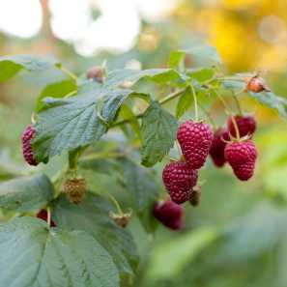

Raspberries (Rubus ideaus) are a self-fertile cane fruit which prefer a slightly acidic soil, which drains well. They are prone to root rot in waterlogged soil, and dislike really chalky soils. They do well in a sunny spot but will tolerate partial shade.
There are two groups of raspberries: floricanes, which fruit on canes grown the previous season (These fruit in the Summer ) and primocanes which fruit on canes grown that year (These fruit in late Summer or Autumn).
Most varieties bear red fruit, but some are yellow, black or purple. All are deciduous.
Raspberries are best planted as leafless canes, usually cut back to about 30-40 cm, in Spring.
Summer fruiting varieties (floricanes) can grow very tall and need support. These varieties will not fruit in the first year they are planted but will flower and fruit the following year. Once the fruit has been picked, these brown canes should be cut out at ground level. The green canes that will grow will flower the year after
Autumn fruiting varieties (primocanes) flower and fruit on the growth made earlier in the same year, and so will fruit the first year after being planted. These tend to be shorter than Summer fruiting varieties, and so do not usually need support. They fruit on the growth made that year, and so each cane can be cut down to the ground in the Spring, ready to start again.
Both types benefit from Fish, Blood & Bone early in the Spring once the ground has thawed, and a top up mulch. Collecting up and disposing of fallen Autumn leaves will improve hygiene and reduce the chance of disease.
Raspberries spread by underground runners.
Raspberries should be harvested as they ripen. When picked, they leave the core of the fruit on the plant and must be handled gently.
They will store for a day or two in the fridge, and should they need to be stored longer, freeze extremely well. Freezing them on open trays and then bagging, means the fruits stay separate and can then be used in the same way as fresh fruit.

