Redcurrants
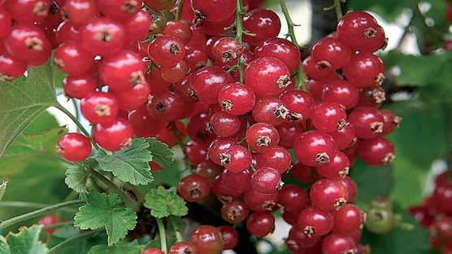
Although redcurrants are closely related to blackcurrants, they are in fact grown more like gooseberries. These cool-climate plants do well in northern regions and will tolerate part shade, although the fruits will ripen more quickly and taste sweeter if given some sun.
Water newly planted bushes well in dry weather, but long-established plants seldom need watering.
Hand weed or hoe carefully to keep the soil free of weeds.
Redcurrants bear their fruit on old wood. Prune bushes by removing diseased or very old branches in winter, then prune new growth back to two buds in early summer to keep plants compact.
In early spring, prune established cordons. Cut the new growth on the main vertical stem by a quarter of the previous year’s growth, or by half if growth is weak. Cut to a bud on the opposite side to the previous year’s cut to keep the growth straight. Once the cordon is at the desired height, cut to one bud of new growth each year in early summer. Prune the shoots from the main stem to one bud to build up a fruiting spur system.
Currants can be harvested in summer when the fruits are firm and juicy. Cut whole trusses and use immediately, or store in the fridge for a few days. Alternatively, place trusses in bags and put into the freezer for later use.

