Strawberry

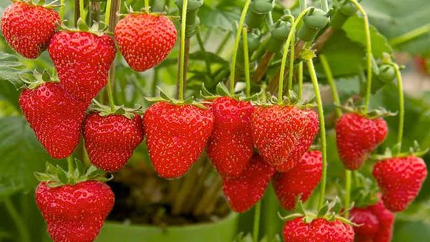
Strawberries are easy to grow. Strawberry plants can be grown almost anywhere – in borders, containers or hanging baskets. And of course, the fruit is extremely popular – home-grown strawberries taste delicious and are great value too!
Water frequently while new plants are establishing. Also, water during dry periods in the growing season. Try to avoid wetting crowns and fruit as this can promote disease.
As fruits start to develop, tuck straw or fibre mats underneath plants to keep fruit clean. This will also help suppress weeds. Pull out any weeds that do emerge. Netting may be required to protect from birds.
After cropping has finished, cut off old leaves from summer-fruiting strawberries to allow fresh leaves to develop. This isn't necessary with autumn fruiting plants, instead just remove old leaves in the end of season clear up. Also remove the straw mulch to prevent a build-up of pests and diseases.
Expect strawberry plants to crop successfully for four years before replacing them. Rotate your strawberry patch onto fresh ground to minimise the risk of disease build up in the soil.

Strawberries are so versatile – they just need sun, shelter, and fertile, well-drained soil. Avoid areas prone to frost and soils that have previously grown potatoes, chrysanthemums, or tomatoes because they are all prone to the disease verticillium wilt.
Strawberries are traditionally grown in rows directly into garden soil.
Runners look like little pieces of roots with very few leaves. Don’t be alarmed, this is how they should look.
Summer-fruiting varieties have the largest fruit. They have a short but heavy cropping period over two or three weeks. There are early, mid-, and late fruiting cultivars cropping from early to mid-summer.

Perpetual strawberries – sometimes called everbearers – produce small flushes of fruits from early summer to early autumn. The crops are not so heavy as the summer-fruiting ones and the fruits are smaller, with the plants less likely to produce runners. Perpetual strawberries are useful for extending the season. If planting in the autumn or early spring, remove the first flush of flowers of perpetual strawberries, but remove flowers of summer strawberries only if the plants are weak.
Grey mould: A usually grey, fuzzy fungal growth which can begin as pale or discoloured patches. Grey mould (botrytis) is a common disease especially in damp or humid conditions. Spores enter plants via damaged tissue, wounds or open flowers. Mould can also damage ripening fruit such as strawberries.
Remove damaged plant parts before they can become infected. Cut out infected areas into healthy tissue and clear up infected debris
Pick strawberries when they are bright red all over, ideally during the warmest part of the day because this is when they are at their most tasty.
Eat them as soon as possible; they do not keep well once ripened. Most do not keep their shape when frozen.
