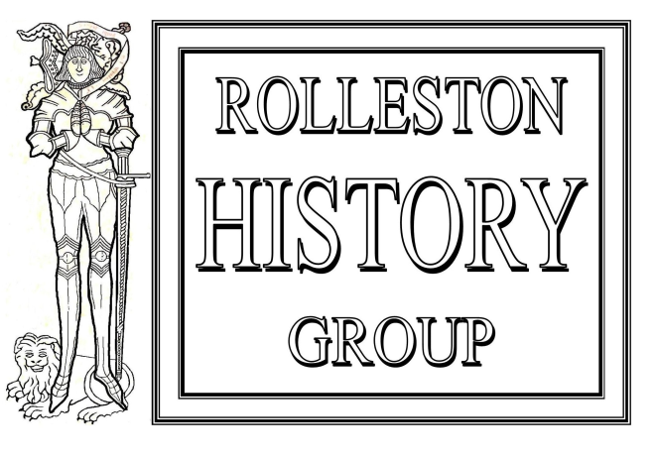
The History Friends

Commemorate

another Centenary

“THE MOSLEYS DEPART”

ST MARY’S CHURCH, ROLLESTON

Saturday 26th October, 9.30 am – 12.30 pm

On the 22nd and 23rd October 1919, in the Co-Operative Hall, Byrkley Street, Burton upon Trent, the feudal Mosley estate, consisting of most of Rolleston and Anslow and parts of Tutbury, was to be sold by auction.

Much of the rural estate transferred to private hands overnight but the sale of the village and Hall dragged on for three more sales leading up to the demolition of the Hall in 1925

The History Friends will tell the story of those sales and also look at members of the Mosley family around that time.

Programme

10.00 - 10.45 The Estate Sales 1919 – 1924 Tom Martin

10.45 - 11.30 Coffee, viewing of Estate sales plans
and pictures of the time

11.30 - 12.15 The Mosleys of the Early 20th Century Arnold Burston
Tickets £5.00 available from

St Mary’s Church Tom & Sylvia Martin, Tel 813320, Email:martin.43@btinternet.com

Arnold Burston, Tel 813457: Michael Wardell, Tel 812565: John Phillips, Tel 813833

All proceeds in support of St Mary’s Maintenance Fund

