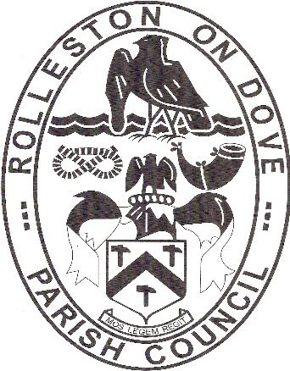

Rolleston on Dove

Parish Council

Clerk: Mrs Mary Danby BA (Hons)
32 Hillcrest Rise
BURNTWOOD
WS7 4SH

Mobile: 07908 545412 (Office hours)
Email: rollestonpc@outlook.com
https://rollestonondovepc.co.uk

BE COVID-19 AWARE WHEN USING THIS PLAYGROUND

HYGIENE
Scientific advice suggests that the virus can survive for up to several days on some hard surfaces.

These risks are reduced when outdoors, where surfaces may be subject to UV light and/or rain. However, coronavirus could survive long enough on frequently used/touched outdoor surfaces to facilitate transmission.

We ask that you protect yourselves and the community by using hand sanitiser before you enter the park and regularly throughout your stay and on leaving the park. Wash your hands thoroughly when you get home for 20 seconds with soap and water.

We also encourage you or any child in your care to:

- Not touch your face
- Cough/sneeze into a tissue then sanitize your hands
- Not to put your mouth on any equipment or put your hands in your mouth
- Not eat or drink in this playground

Please place all litter including cleaning equipment, tissues, gloves and masks in the bins provided. If these bins are full then please take your rubbish home with you.

You can further help your community by rubbing down touch points on equipment that your child will be using or has used with suitable cleaning fluid.

SOCIAL DISTANCING
Social distancing aims to reduce social interaction between people to minimise the opportunity for transmission of COVID-19.

You should aim to keep 2m apart from anyone who is not a member of your household. This may mean that you need to, or encourage your child or children to:

- Only have 1 adult supervising each family group
- Wait at a distance until others have finished using the equipment
- Choose equipment that allows for a 2m distance between users, such as leaving an empty swing between each child
- Avoid using benches that are already in use

