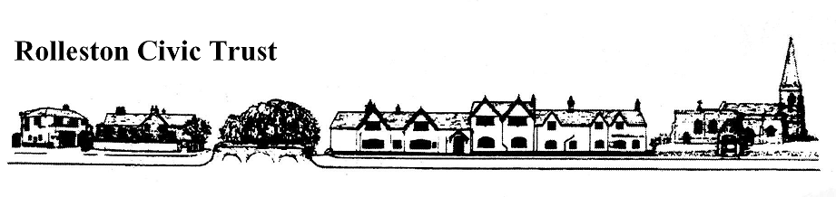
Rolleston on Dove Treasure Trail
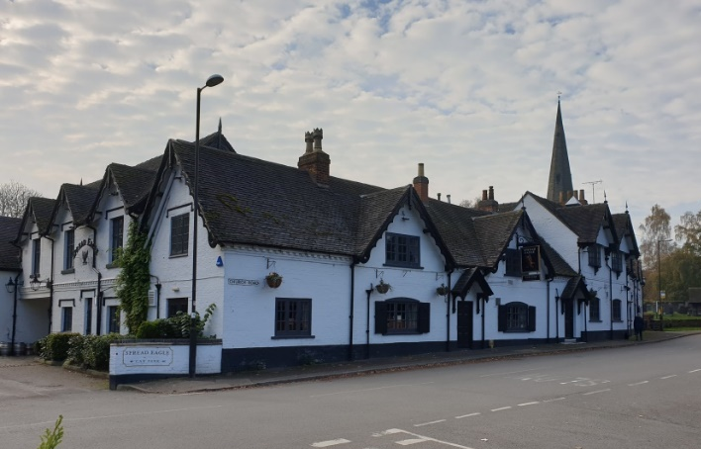
Can you follow the Treasure Trail and find the answers to all the questions shown below? How many points will you get? Award yourself 10 extra Bonus Points for taking a ‘Selfie’ with any of the Civic Trust Award Plaques you see.

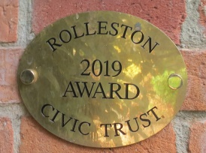
The Trail is around 2 miles in length and should take around 90 minutes. It doesn’t visit every part of the village but it should show you the main highlights that the village has to offer. The trail is divided into sections that are numbered. Find the answers on each section of the trail. Please stay on paths and do not enter anyone’s private property. Good Luck!

The Trail begins at the car Park on Craythorne Road Playing Fields.
(DE13 0AZ is Craythorne Farm – the car park is 150 yards down the hill towards the village, on the right).
Scoring: Give yourself five points for every correct answer unless stated.
There are FIVE Civic Trust Plaques to collect on the route – four made of brass and one of wood.
Award yourself 10 points for each one. Write the years of the awards here:
- ………………………
- ………………………
- ………………………
- ………………………
- ………………………
Somewhere on your route you will see a sign. This is an anagram of it.
BONY LIONEL WORKSHOPS. Solve the anagram to earn 10 points.
Anagram Answer ……………………………………………………………………………………………………….
- Leave Craythorne Road Car Park by a small gate leading into the woods. Follow this path in a straight line, through another gate and down a path towards the village. This will bring you to Beacon Road.
- Turn RIGHT on Beacon Road. As you head straight on towards the T- junction with Station Road can you find;
- A symbol of love ………………………………………………………………………………………….
- The year of the 18th Century that a house was built. ……………….……………………
- Somewhere where you might collect apples ……………………………………………….
- A precious metal ………………………………………………………………………………………….
- The date the school building was built. ……………..…..…………………………………….
- At the T-Junction turn LEFT and cross Station Road where it is safe and head past the garage, can you spot;
- Who approves the vehicle testing? ……………………………………………………………….
Turn right after the Garage and head towards the village ford (by the old Brookhouse Hotel) and cross the bridge.
- As you walk across, how many posts are there on the left-hand side of the bridge along the whole rail………………………………………………………………………
Brookside, a picturesque village lane, once the main route from Stretton and Claymills, fully lives up to its name. Cottages flank its north side as it follows the course of the Alderbrook
- As you follow the path down Brookside, heading towards the Spread Eagle Pub, can you find;
- Where the Public Footpath goes to? ……………….……………………………………………
- A Beatrix Potter character. ……………………………………………………………………………
- A mode of people powered transport. ………………………………………………………….
- At the village sign and the island surrounded by railings, can you find;
- The number of birds on the village sign? ………………………………………………………
- Who is the sign in memory of? …………………..…………………………………………………
- Who was the first President of the Civic Trust? ………………….………………………..
- Which bird can be seen on the bridge? ………………….…………………………………….
- Who was the last village Blacksmith? ………………….………………………………………..
The Spread Eagle Inn and Restaurant, dating from circa 1820s, has expanded to include adjoining cottages and a wing, once the “Girls’ School”, in later times.
Cross the road (safely) and walk to the RIGHT past the pub, as you go…
- Can you find information about who The Spread Eagle was named in memory of? ………………………………………………………………………………………………………………..
Saint Mary’s Church – a place of worship has stood on this site since the early 12th century; the presence of a priest is recorded in the Domesday Book. The present church was built during the 13th century, its south aisle housing memorials to the Mosley family. Built in 1919, the lychgate is dedicated as the village war memorial. Did you know in the churchyard there is a Saxon cross, thought to be over 1000 years old – the only complete example in the whole of Staffordshire.
- As you enter the churchyard through the Lychgate find…
- The time of evening worship? ……………………………………………………………………………..
- What is written on the front of the Lychgate? ………………………………………………………
Head into the churchyard, follow the path to the RIGHT, towards the Old Grammar school and then left towards the Village Green. As you walk, keeping to the path, can you find;
- A town in Derbyshire ……………………………………………………………………………………
- A servant in a stately home ……………….…………………………………………………………
- A fruit drink maker …………….……………………………………………………………………….
- Head onto the village green and look all around for the following answers;
- What year will the time capsule be opened? ……………………………………………….
- What did the Civic Trust donate to the village in 2018? ……………………………….
- The Oak Tree is a seedling from which special tree? …....……………………………..
- What is the name of the Village Green? ………………………………………………………
Head towards the bridge near the Almshouses.
The Almshouses, their lawns skirting Alderbrook, were built in 1712, their thatched roofs being replaced with slate in 1833 and eventually tile in 1893.
- At the Bridge cross over onto Burnside and turn RIGHT. As you continue on the pavement towards The Lawns;
- How many blue Almshouses front doors are there? ……………….…………………….
- What can you see on the door of number 2? ………………..………………………………
When you reach The Lawns, turn right into the estate and cross the road into Brook Hollows Spinney. Can you find;
- The name of the Hairdressers? ………………………………………………………...............
- The phone number for the Open Spaces Team? ………………….……………………….
- Who is the bench in memory of? ………………….………………………………………………
Brook Hollows Spinney is an area once part of the Mosley estate, the lake being one of a series of fishing and pleasure lakes dug along the Alderbrook.
- Cross the bridge over the waterfall
- Can you count how many pillars there are on the bridge? …………………………………
Follow the path to the LEFT down some steps and look back and enjoy the waterfall. Follow the path back to the road and turn LEFT re-tracing your steps along Burnside toward Rolleston Social Cub. Along the route;
- What do the 2 businesses next to the Co-op offer? ……………………………………………
- Find roads that are named after a Queen and a bird. …………………………………………
- Who laid the cornerstone to the Rolleston Club? ……………………………………………….
The Commemoration Hall, also known as Rolleston Club, the earlier part of the building dating to 1897, was erected to commemorate the diamond jubilee of Queen Victoria.
- From outside the Rolleston Club follow the pavement to the end of the road and round to the RIGHT. Along this route can you spot;
- 3 old village businesses that are now houses. Name them. (15 points)
……………………………………………………………………………………………………………………………………
- Follow Station Road over a side road and turn RIGHT down Chapel Lane. As you walk along this route and down Chapel Lane towards Beacon Road find;
- A road where Scottish people might live ………………………………………………………
- Houses that are named after different flowers/plants. (25 points) …………………………………………………………………………………………………………………….…………………………………………………………………………………………………………………………………………………
- What date was the Chapel built? ………………………………………………………………….
- Add up the digits of the Butcher’s phone number. ………………………………………
- When you reach Beacon Road turn RIGHT. Find;
- A cottage name with the number seven in it. ……………………………………………….
The footpath you came down is now on your left. Follow this path back to the Car Park. You have then completed the Treasure Trail! WELL DONE!!
To claim your 10 EXTRA points for a Selfie with a Civic Trust Award plaque, you must post the photo on our Facebook Page @RollestonCivicTrust or email it to us.

Scoring: Including the 10 Bonus Points, a perfect score for the Trail is 300.
Anything over 250 is a good score! Why not let us know how many you scored!
To obtain the answers to the Treasure Trail send an email (after you have completed the trail) to rollestonct@gmail.com

Please follow us for information on other future events In Rolleston. If you enjoyed the Treasure Trail please make a donation to the Civic Trust – just ask us for details to do this.

Contact us: rollestonct@gmail.com If you would like to become a member of the Civic Trust, it costs just £5 a year per household. Rolleston Civic Trust is a registered charity.

